# Express

**Express is a minimal and flexible Node.js web application framework that provides a robust set of features for web and mobile applications.**

**Express isn't adding anything to the C++ side of the Node core. Everything Express is doing are things that you could have coded yourself. It's just a lot of JavaScript code taking care of a lot of very common things in a really great way, which is why it is very popular.**

1) What is the purpose of it with Node.js?

That you don't have to repeat same code over and over again. Node.js is a low-level [I/O](http://en.wikipedia.org/wiki/Input/output) mechanism which has an HTTP module. If you just use an HTTP module, a lot of work like parsing the payload, cookies, storing sessions (in memory or in [Redis](http://en.wikipedia.org/wiki/Redis_%28data_store%29)), selecting the right route pattern based on [regular expressions](http://en.wikipedia.org/wiki/Regular_expression) will **have** to be re-implemented. With Express.js it there for you to use.

2) Why do we actually need Express.js? How it is useful for us to use with Node.js?

The first answer should answer your question. If no, then try to write a small [REST](http://en.wikipedia.org/wiki/Representational_State_Transfer) API server in plain Node.js (that is, using only core modules) and then in Express.js. The latter will take you 5-10x less time and lines of code.

## 73. Installing Express and Making it easier to build a webserver

Node.js has the ability to help us build a web server,it's time to make that process easier,with one of the most popular ways to do that and in fact, one of the most popular packages on the npm registry.It's time to talk about Express.

Now in your visual studio code go to terminal and first create a project by npm init (it will create a basic package.json file)

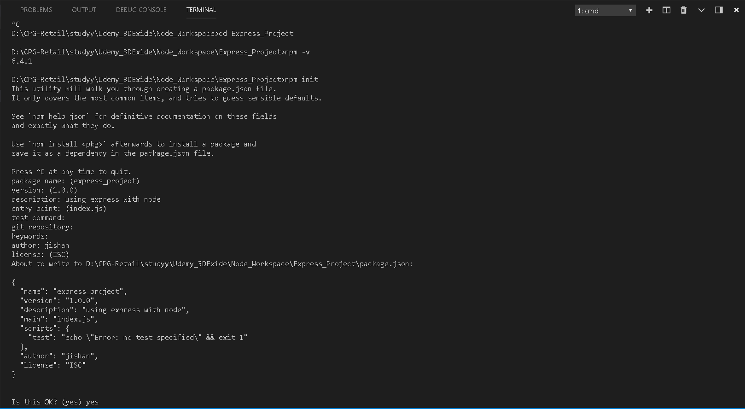

But I haven't downloaded anything yet, so there are no dependencies.

So, first, let's instal Express. Express is available on the npm registry, and it's just a bunch of JavaScript code.

So, we can go to the command line and type npm instal express, and I'll use -- save to put it as a dependency in my package.json

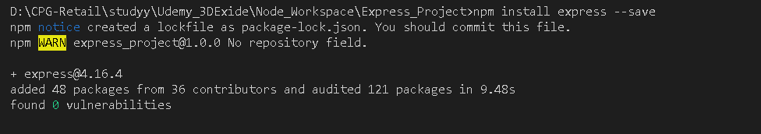

because Express is just JavaScript wrapping the kind of code that we've already seen before. And so, that means that it needs to be there, if I'm going to use Express, to run it properly.

Express gives me, via the Node module format, access to a bunch of JavaScript code that other people wrote.

So, let's install it, which really means just download these JavaScript files. And it goes ahead and grabs it from npm, the registry. And note that now, in my node_modules folder, there's an express folder.

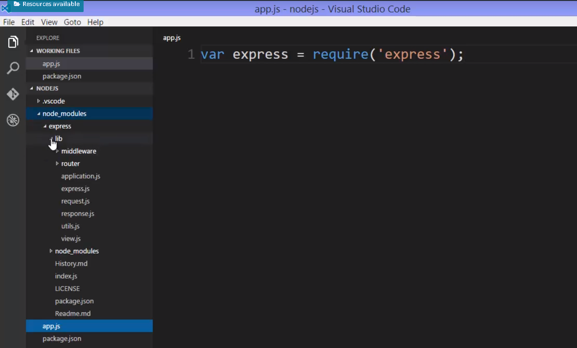

So I can go ahead and use Express in my app. To do that, I'll just use the require function. So, I'll call my variable express, and require express. Since it's installed in the node_modules folder, then the require function will know to go out and look there and grab it.

And, if I want to know exactly what I'm getting, I can actually go into the express folder and look at the code.

**So, the index.js file in the express folder in node_modules, that's where require is going to look.**

**Remember, if you have a whole folder of code, we put an index.js file in the folder,and then, we can require that folder, as opposed to an individual file.**

So what's being exported is actually the contents of express.js, in the lib folder.

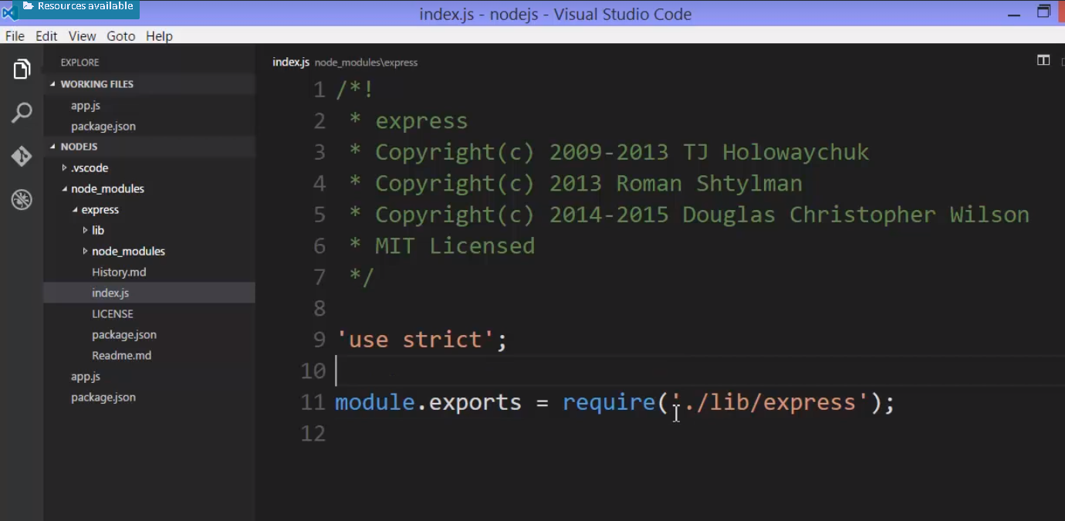

In express.js file, it's using some various things, but what it's exporting, and thus, ultimately, what's being exported from the express folder, is createApplication.

And createApplication is a function. But notice it's not a function constructor. It actually returns a value. So I need to call this function. And what it returns is a function. And, again, it's not returning a function constructor, it's returning a function.

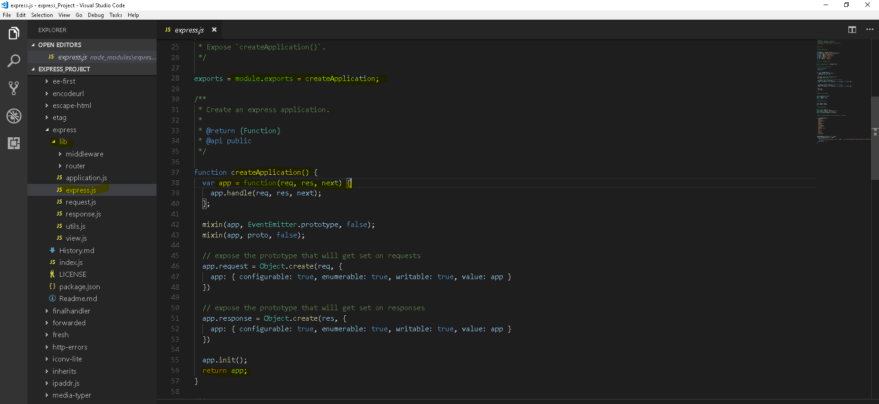

As express returning a function, So, I need to call this,but what this gives back to me itself is a function. And because functions are first class, because functions are objects in JavaScript, the creators of Express chose to add properties and methods directly to that function. So, you can add properties and methods to a function, just like any other object, because a function is an object.

So, it has an init function. There's a request and response property that looked to be wrapping the standard Node request and response objects. It adds on an application, a router, query, this thing called static, all coming from other code, so it's combining various code that's sitting in here and making it accessible to this function that's returned from createApplication.

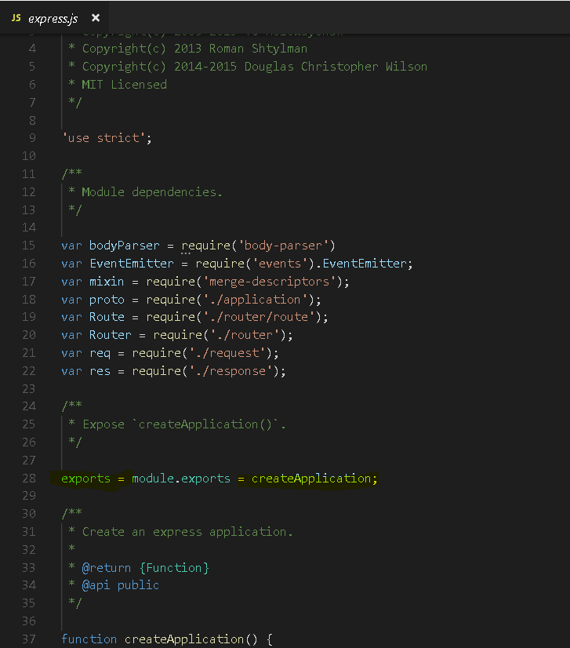

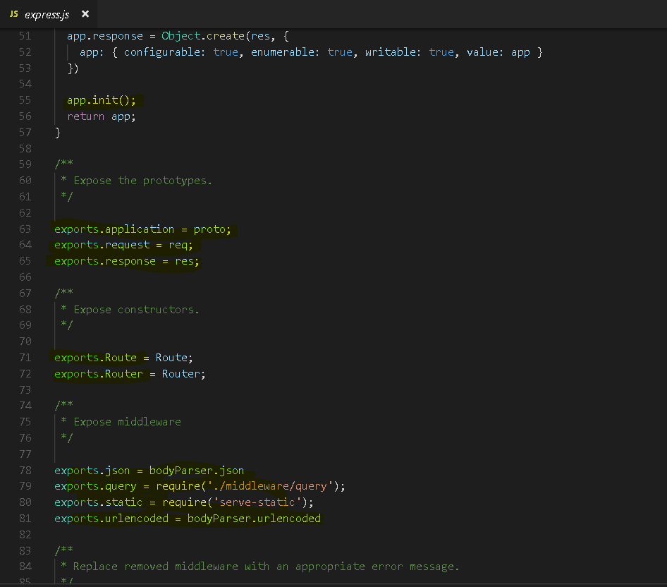

**So, that means, in my app.js file, to actually get this, usually we call it app. I'll have to invoke the function that was returned from require. And now, this will also be a function, but it's a function that has some properties and methods on it, because functions are objects in JavaScript. So now, I can use this.**

This is a working Express app.

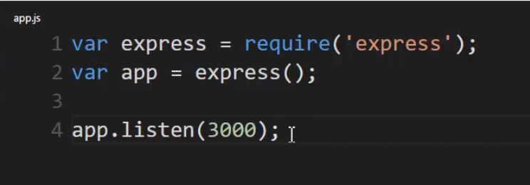

**And one of the first things I'll do is to find, in application.js, inside the lib folder,** **inside Express, it adds a listen function. And see what it does? It just does what we did before. It calls the standard core Node HTTP object and the createServer method**. 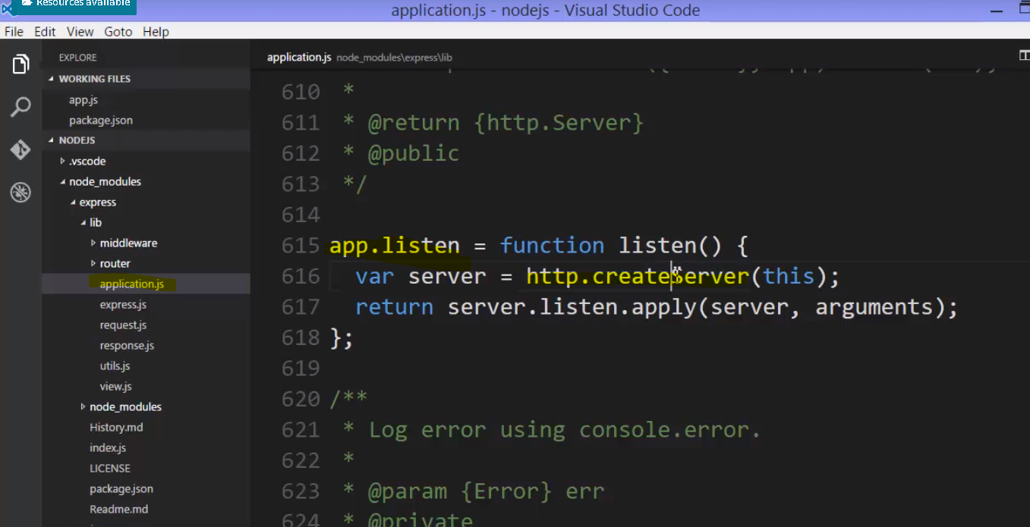

We've already used that. But, instead of doing that, we simply say, app.listen, and then give it a port. And if you look at the Express documentation, they often use port 3000 in their examples. So we'll use that too.

So now, I'll have an HTTP server running, based, although, just on that Node core.

**Notice Express isn't adding anything to the C++ side of the Node core. Everything Express is doing are things that you could have coded yourself. It's just a lot of JavaScript code taking care of a lot of very common things in a really great way, which is why it is very popular.**



So, each server could have a specific value set, some setting, and we can read that value and respond, and that way, we don't have to change our code in order to change a setting. There might be a way for the server to set the environment variable, and even though our code responds to it, we're actually setting the variable outside of it. And this, we end up doing a lot when we're dealing with node being deployed to servers.

so let's suppose, on your local box, you want to run and listen to port 3000. But on your testing server, it might be a different port, and on actual production, it's another. So, we can use environment variables for this.

**So let's say I set a variable called port, and I can use process, which is provided by Node, as a global object, essentially, .env., and then whatever environment variable I want to access.**

it may be a standard one, and it may be one that's added as an extra on the server.

So, let's suppose that we'll have a port variable set on the server, and so, I'll be able to access it through process.env, dot whatever the variable is. And then, I can use a JavaScript trick to set a default value.

**Var port = process.env.PORT || 3000**

**app.listen(port);**

And so this means this variable port will be either equal to the environment variable, or if this doesn't exist, which it won't, on my local box, 'cause I haven't set up this environment variable, it will be equal to 3000. So, again, it will be either there is an environment variable called port, and that's what it will be equal to, or, if not, a 3000. So on my local box, it will be 3000, because I haven't created this environment variable in the command line or any other way. But on many servers, when you're deploying Node, you can set up environment variables. So, on Node, you could set up a port variable, maybe 80, on production, and that's what the app will listen to when this code is run in production, because the environment variable will exist.

**what about responding to the URL, the way we did with those if statements, originally?**

Well, Express comes with a much, much better way to deal with that. We'll say app, that is, that function that came back from invoking Express, that came back from actually requiring it, and it has on it various methods that map to HTTP methods, or verbs.

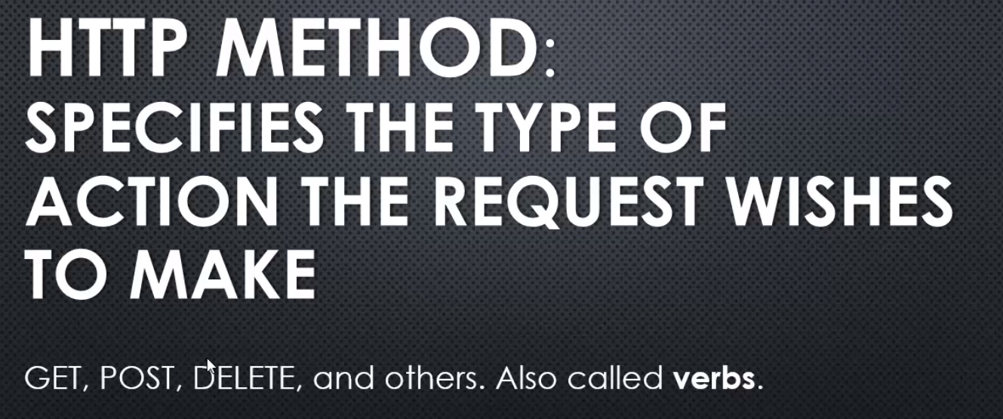

**Now, they don't actually do anything in themselves, because it's just some text, a piece of data, that is coming along for the ride as part of the HTTP request. However, it's up to the server, then, to do what is expected to be done with one of those HTTP methods.**

For example, when you're just getting data, like downloading something or just getting a web page, it's a GET request, but when you send the contents of a form, you click the submit button on a form, it's usually a POST that's being sent. Ultimately, it's really, basically, just an HTTP request with a bunch of data, and one says GET and one says POST. And the one that says POST might have some data inside the request to go along with it. But, we want to then respond properly to each of these different kinds of HTTP methods.

**Express built in a way to then map what you see is the verb in the HTTP request to a particular function that you want to run when that request comes in.**

So if I just say slash, that will be, essentially, the home page. And I give it a callback function. So what this does is does something similar, but more powerful, to when we had our if statement, looking at the URL.

**An HTTP request comes in. This is the URL. And it's a GET method. It's a GET verb, in the HTTP request.Then this function will fire. And it will give me a request and a response. Just like we did before, but this will be an Express request and response, which wraps up the standard HTTP Node request and response, and provides a bit more functionality to make things easier for us.**

**Notice that I'm not putting a content type of text slash HTML or something like that.**

**The Express methods and the response object that wraps up the standard response object actually looks at what I'm sending and takes care of that for me to the best it can.**

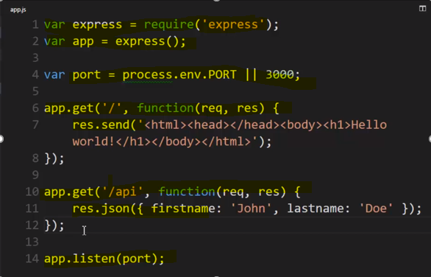

## 74. Routing

expressjs.com - It has a tonne of absolutely terrific documentation on what you can do, what kind of things you can match. You can go to the guide and go to routing, and it will talk about some of these things. But here there is a whole wealth of things that you can do, as far as matches are concerned. Meaning that, we can search not just for a particular url, but for matching patterns.

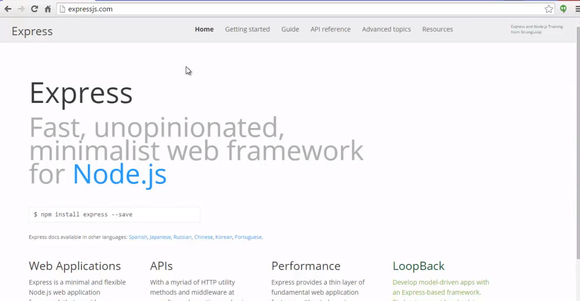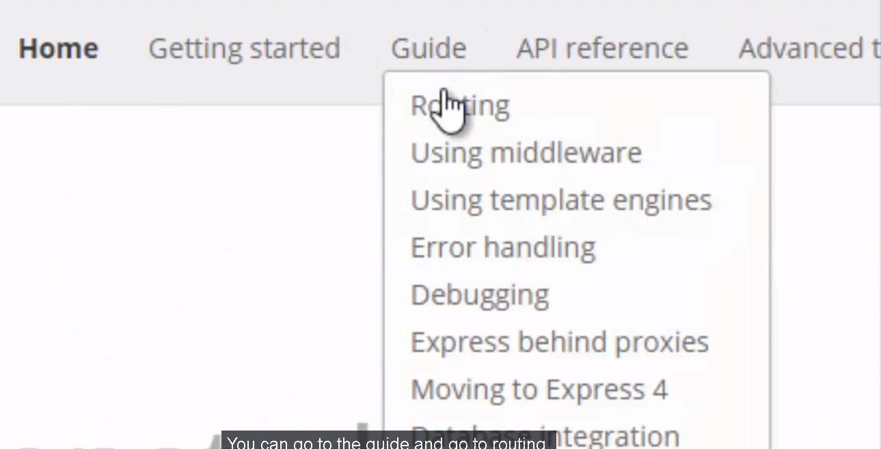

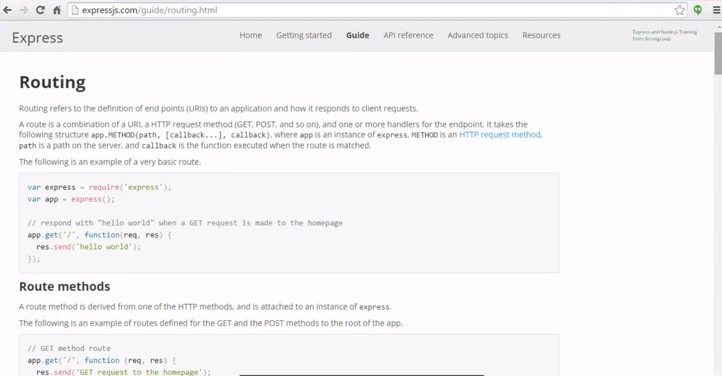

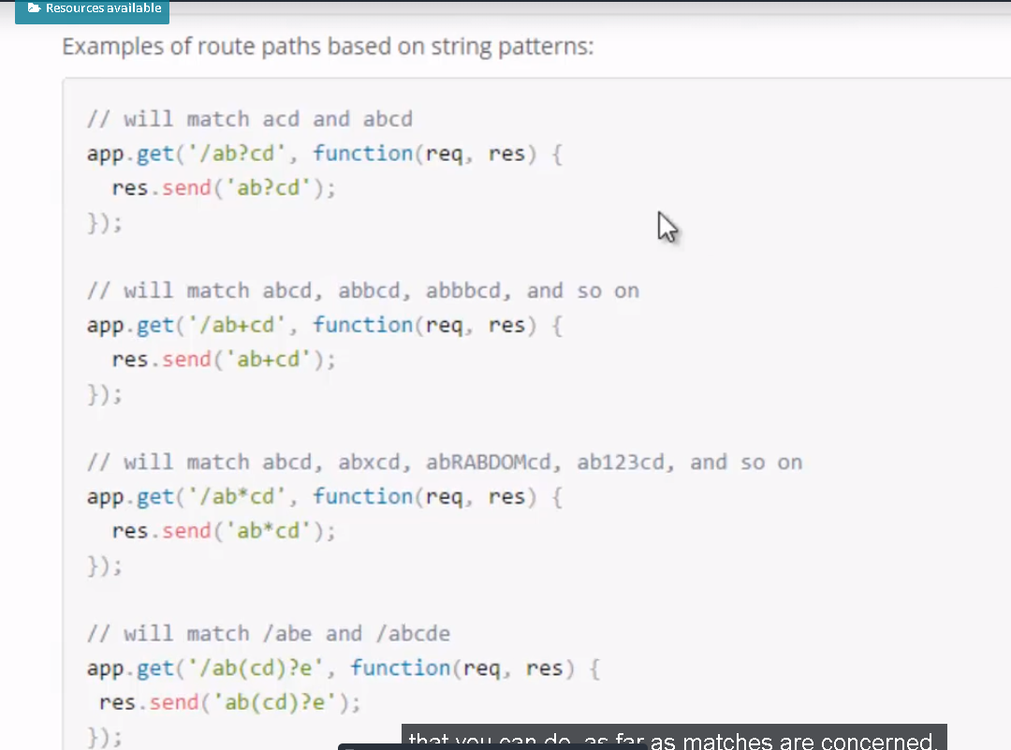

But here(above) there is a whole wealth of things that you can do, as far as matches are concerned. Meaning that, we can search not just for a particular url, but for matching patterns.

Let's try adding a different kind of route.

One that has a variable in it. So, I'll make a new route and let's say, /person, so any url that starts with /person and then /, and then I'll say :id.

**This is my variable name and the colon, tells Express, the JavaScript code in Express, that this could be anything. So, if the url that is requested in http request, is /person/something, this function will be run.**

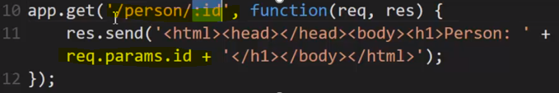

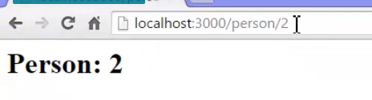

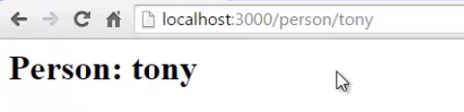

this was matched, it looked for and allowed anything to be there. Ran this function, and then I output it as the http response, this HTML and I went ahead and included this value that Express put on this params variable for me, and this could really be anything. It could be tony.

So this is a way to use the url and pull data out of it, data that might change.

**you could have multiple parameters in url.**

**You could have person/:page/:id and these would be two different variables.**

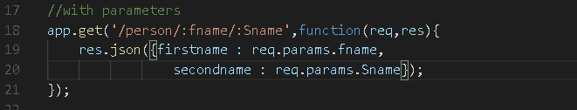

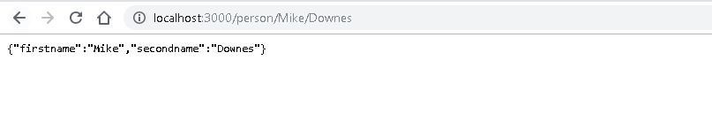

It does pattern matching and it does a variety of pattern matching and let's me pull out specific values in the pattern. And so i have full flexibility on dealing with my routes and I don't have to do too much work, in order to make this happen.

**Note - More about routes, app.route() , express.Router in expresjs documentation and Routing.docs.**

**Basic example of express.Router() –**

**Use the express.Router() class to create modular, mountable route handlers. A Router instance is a complete middleware and routing system; for this reason, it is often referred to as a “mini-app”.**

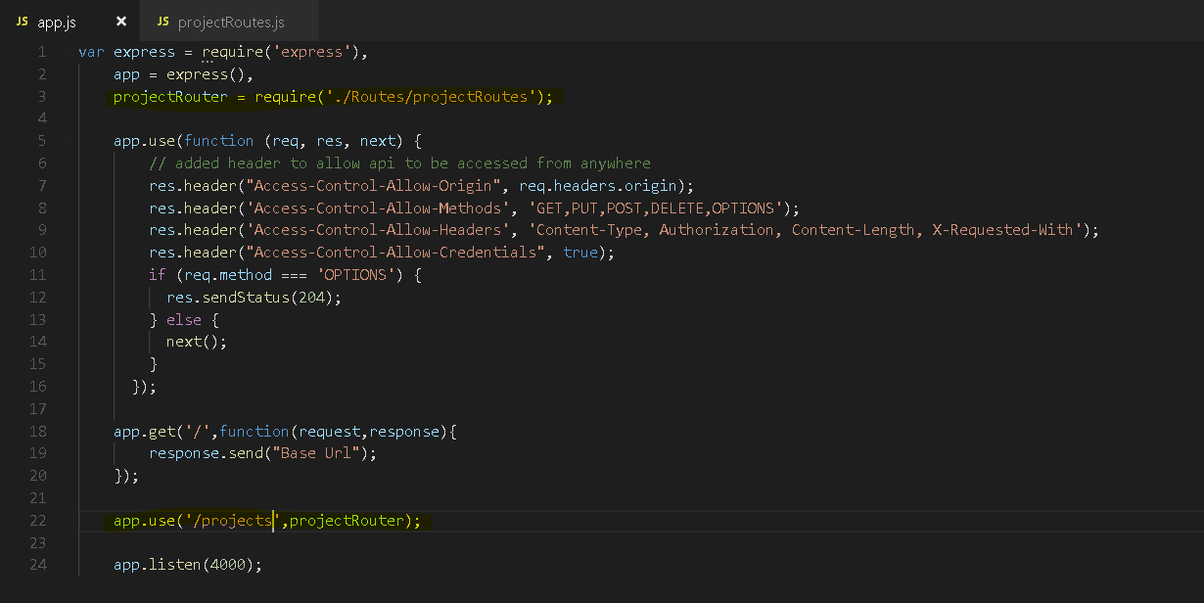

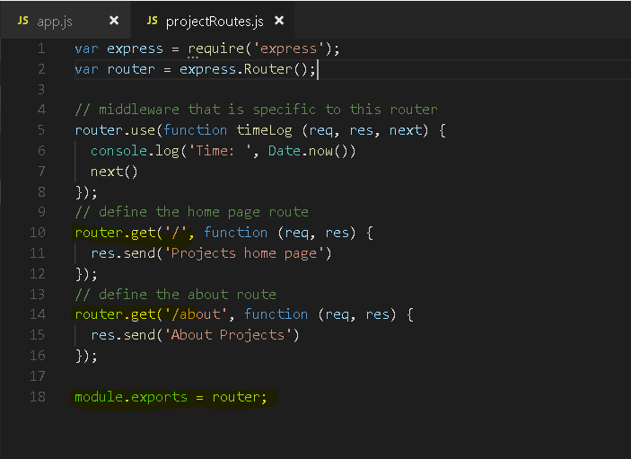

**Output –**

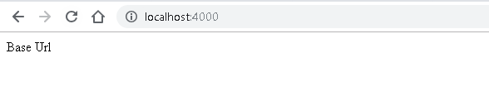

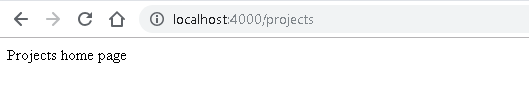

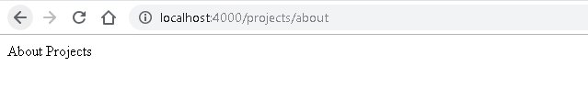

## 75.(Middleware) Static files and Middleware

**there are a lot of scenarios that are very common that happen between that request, processing the HTTP request, and giving an appropriate response. It would be awfully nice if there was an easy way to specify the things that should happen between there and even have common plugins for what should happen between the request and the response**

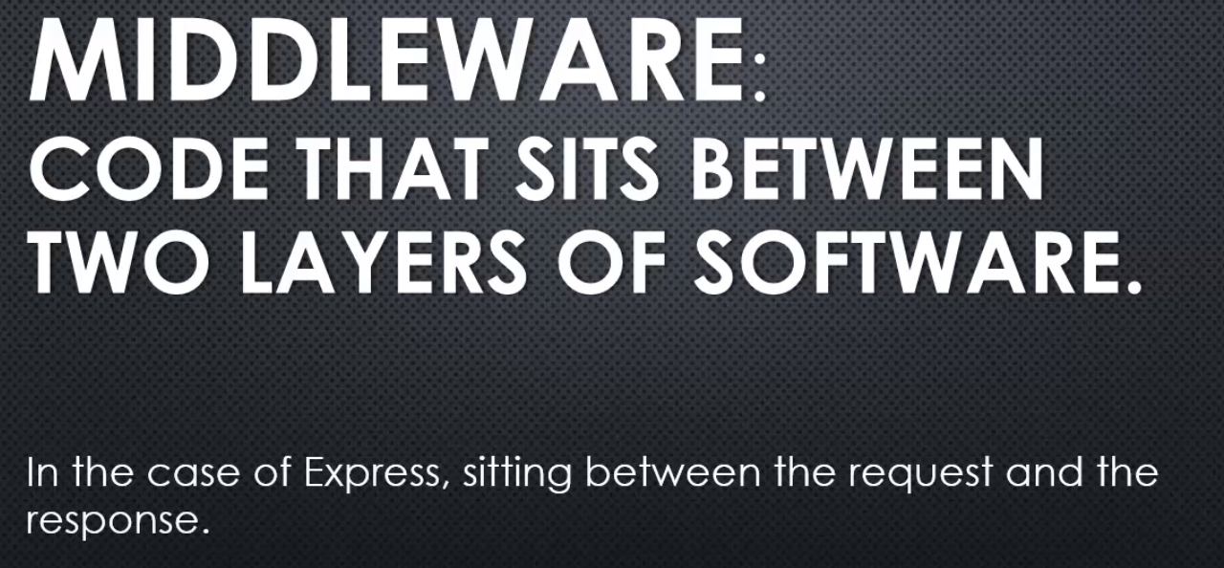

I have some middleware that does something for me,

Express provides an easy way to plug in middleware in between the request and the response to handle certain requests, providing certain responses automatically, and to even have multiple levels of middleware where a request and response is handled, then moved onto another piece of middleware that does something more, etc.

A very common scenario might be that I need to handle files being downloaded.

Remember, it's just an HTTP request, so I need to manually deal with every kind of request that comes in for things that make my application work.

So for example if I have a CSS file, a stylesheet file, that defines what my application looks like on the Internet in the browser, then the browser is going to request it. It's going to make an HTTP request to get that CSS file, and I don't want to manually deal with that. I just want whatever files, CSS files, image files, etc., that are just sitting on the server, if they're requested in that URL then they should just be hooked to and streamed automatically to the response. I don't want to have to manually respond to every file that I might put of that kind, that is to say static files.

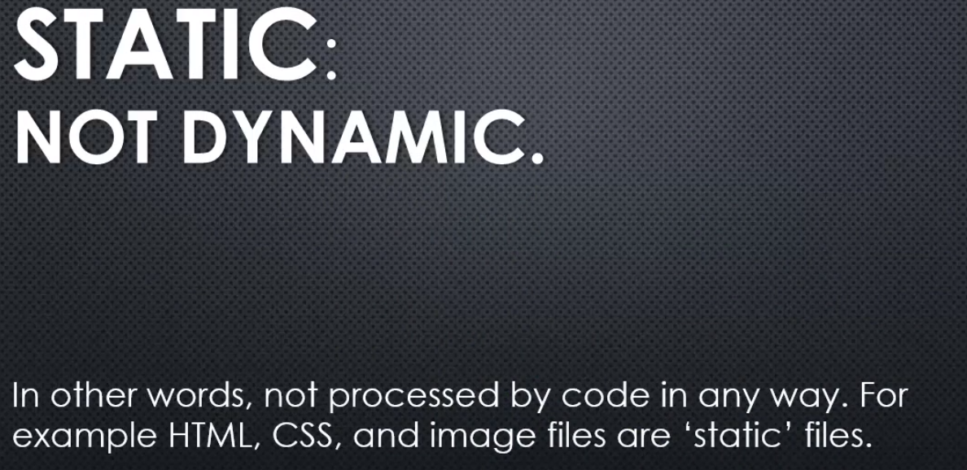

**but we still need to deliver them when they're requested via an HTTP request.** Remember, the request doesn't somehow connect to the file. We're just getting the request and the server has to decide what to do with that. So let's say I want to add some static files to my application. This way I, or a designer, or anyone could just push these files into the application and they'll just be properly downloaded. We won't have to deal with what happens between the request and the response.

We'll add some middleware that will do it for us.

We'll start by adding a new folder. Now this could be anything you want to name it. It's very standard to name it public where you sit your static files. Then I'll make a new file, let's say style.css, and in this file I'll just change the font family the entire site uses.

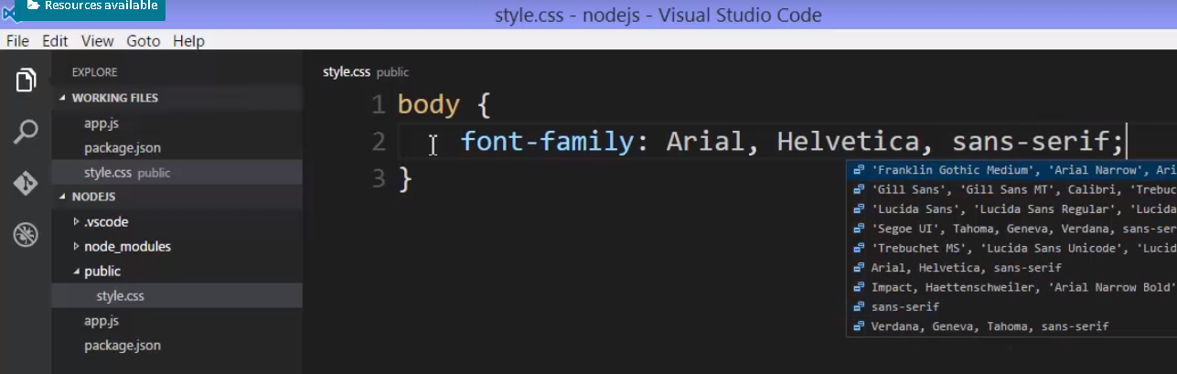

**then I want to use this style. So, how am I going to make sure that this file can be downloaded when it's requested via an HTTP request. I'll use middleware.**



I'll say app.use,

and it is basically what it sounds like. We'll use some middleware, and we'll first match our route. So, we could say public here, or I could name it whatever I wanted, because I'm going to map a route to those files on the file system, so they don't have to match as far as names are concerned.

So, if there's an HTTP request for let's say assets, then I'll respond with some middleware. Built into Express is some middleware called static.

I say express.static and then say where to find the file physically.

**"Well, every time we see /assets "and then we see slash some file," what I'll actually do is go find this full file path, public, that's where I decided to put them, and then look for that same file and stream the response back, and that's all I have to do. Any static file then I'd put inside the public folder would become available.**

So, let's add this quickly to our HTML. I'll do a link tag and an href, and I'll say, asserts/style.css. And the link tag can have a type, text/css, rel=stylesheet, and close it, and that's just a standard stylesheet link tag.

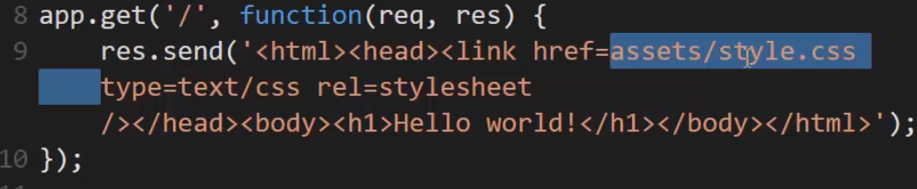

**So, the browser is going to download this HTML, see this link tag, and generate an HTTP request for my site / assets/style.css. That HTTP request will be handled by Node, and when it sees the /assets part it will say, "Okay, anything after that "I will look for it in this folder."**

**This is middleware between the request and the response, and it will respond by streaming back this file for me.**

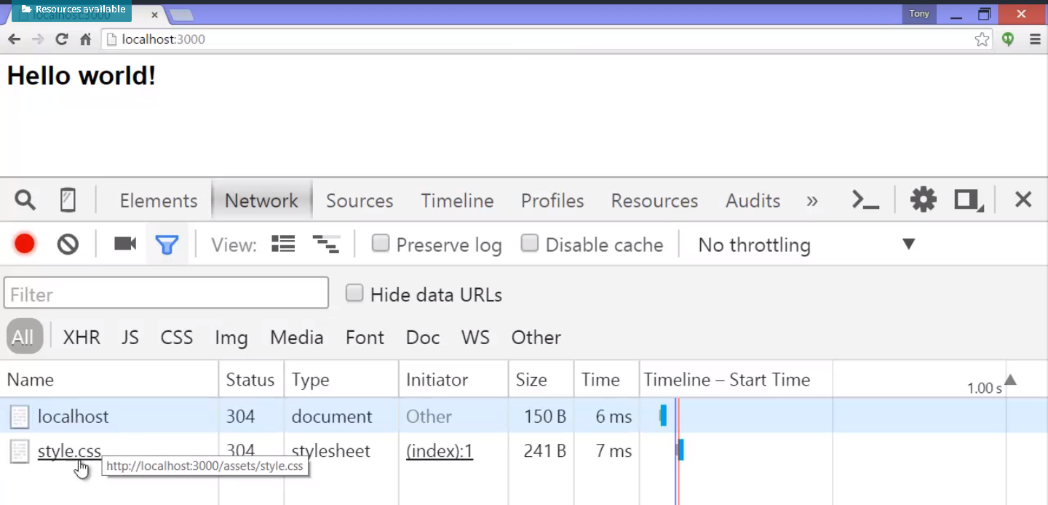

**There was my request for the HTML, and then the browser saw the link tag and generated that second request for the style.css.**

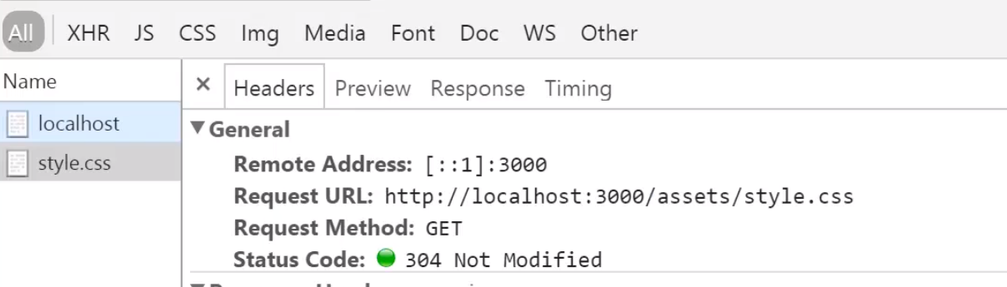

node caught that, saw the /assets in the URL and said, "Let's pass it to that middleware." And the middleware said, "Okay, I'll look for this file "in that public folder," because that's where we told it to look, and it streamed it back, and we got the file back in the browser.

**So now I could put images, I could put subfolders, I could put other stylesheets, I could put whatever I wanted in there that was purely static content and any request Node would properly handle because I have the middleware installed for it.**

Now, you might be wondering can I make my own middleware?

Absolutely, because app.use just matches a route and then takes a function.

Like express.static when you invoke this it returns a function, which then handles the request and the response, what's in between there, and also something, a third parameter, that we'll call next.

So what this means is that whenever this route hits this function will be executed, just like with my get method, and then I could do something. So, let's say I had console.log('Request URL, and then I'll grab the URL from the request. Then, I'll say next, I'll invoke that.

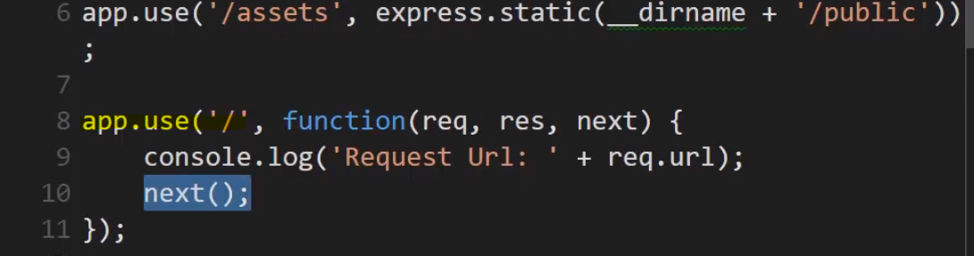

**This is something that Express provides for middleware to the function that you give as the callback when the route is matched.**

**What this means, and all it means, is that run the next middleware.**

If you think about it,

**these get methods are middleware. I'm capturing a request and doing something before the response is sent. So, between the request layer and the response layer of Node and Express I have something in between.**

I'm sitting in the middle, and so I can do whatever I want when that particular request comes in, and then say, "Keep on going. "Call the next middleware that is in some way connected "to this particular route."

Output –

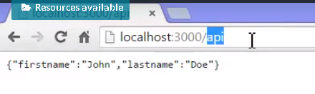

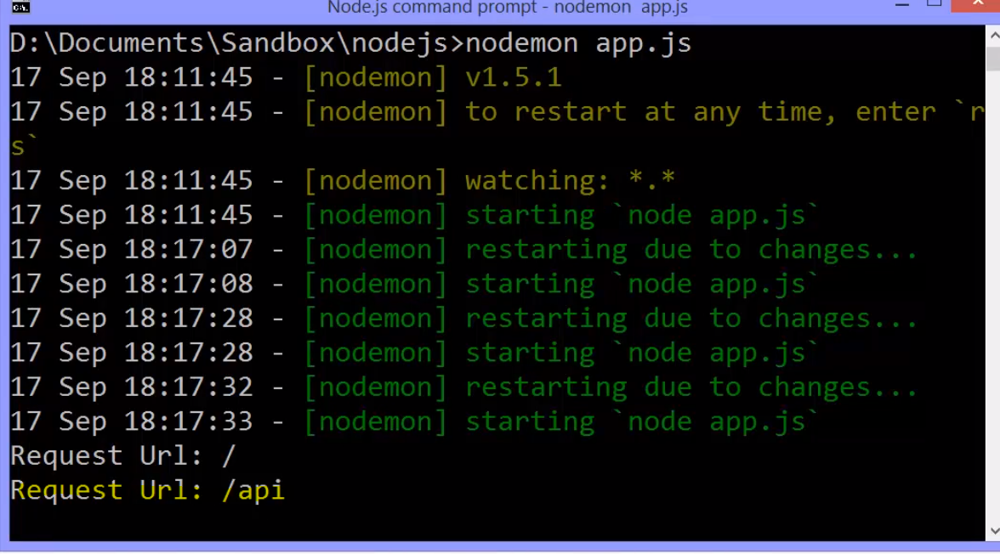

So this idea of middleware and connecting middleware together is very powerful because it lets me build reusable ways of dealing with HTTP requests and responses.

**I can use other people's middleware, like Express's static middleware, to save me time, and I could do whatever I want with the request and the response, and I can specify it according to the route.** **You can actually leave off the route when it comes to .use and it will just happen for every request no matter what the route.**

So you could have a logger. You could have something that deals especially with uploads or downloads, or whatever the case is.

Since we're talking about JavaScript code freely available, other people's code, other people's middleware for Express, where do you think ultimately you go to be able to install those things?

npm, of course, the npm registry. And while under the Guide there's a Using Middleware section on the Express website, there's under Resources, Middleware, I have a nice list which connects to the GitHub repo, and each of the GitHub repos tell me how to install these middleware into my application.

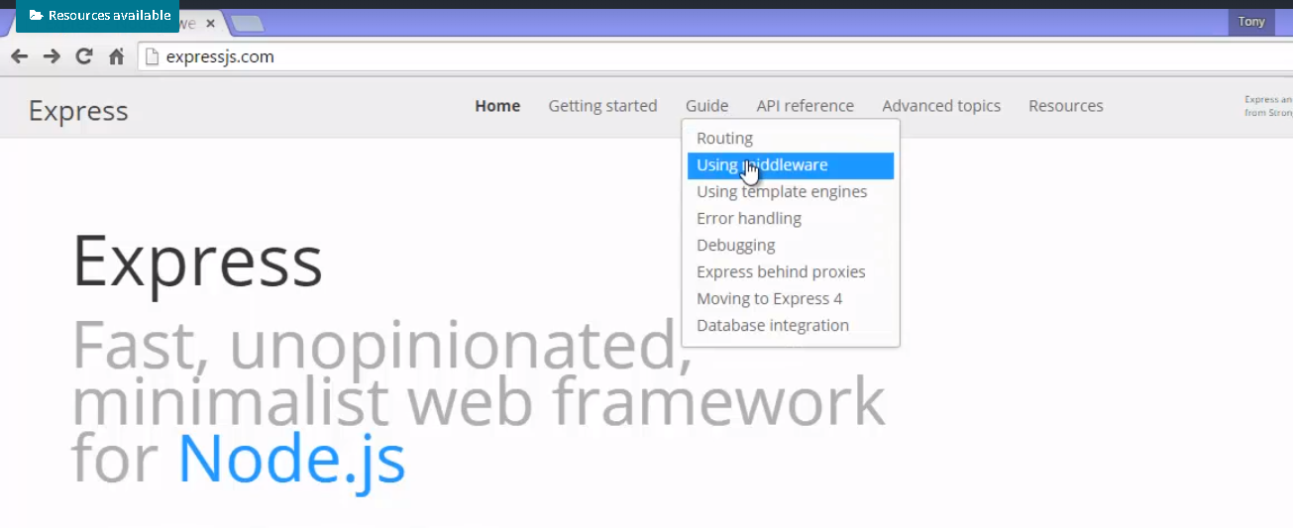

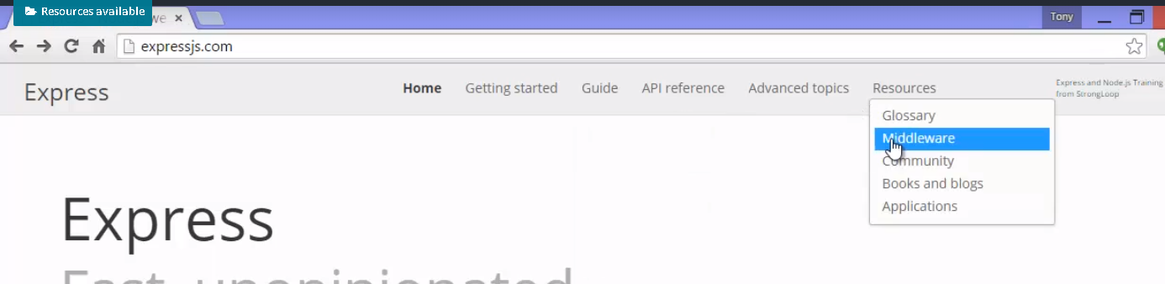

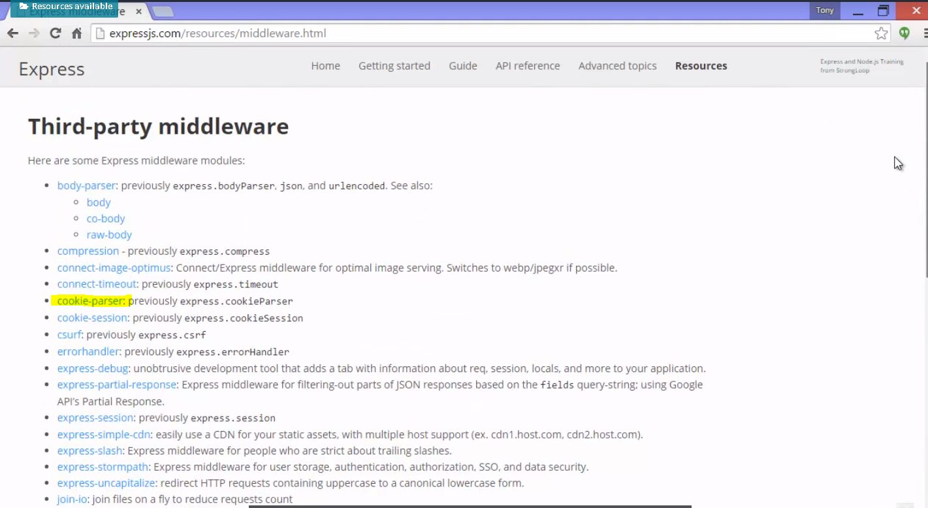

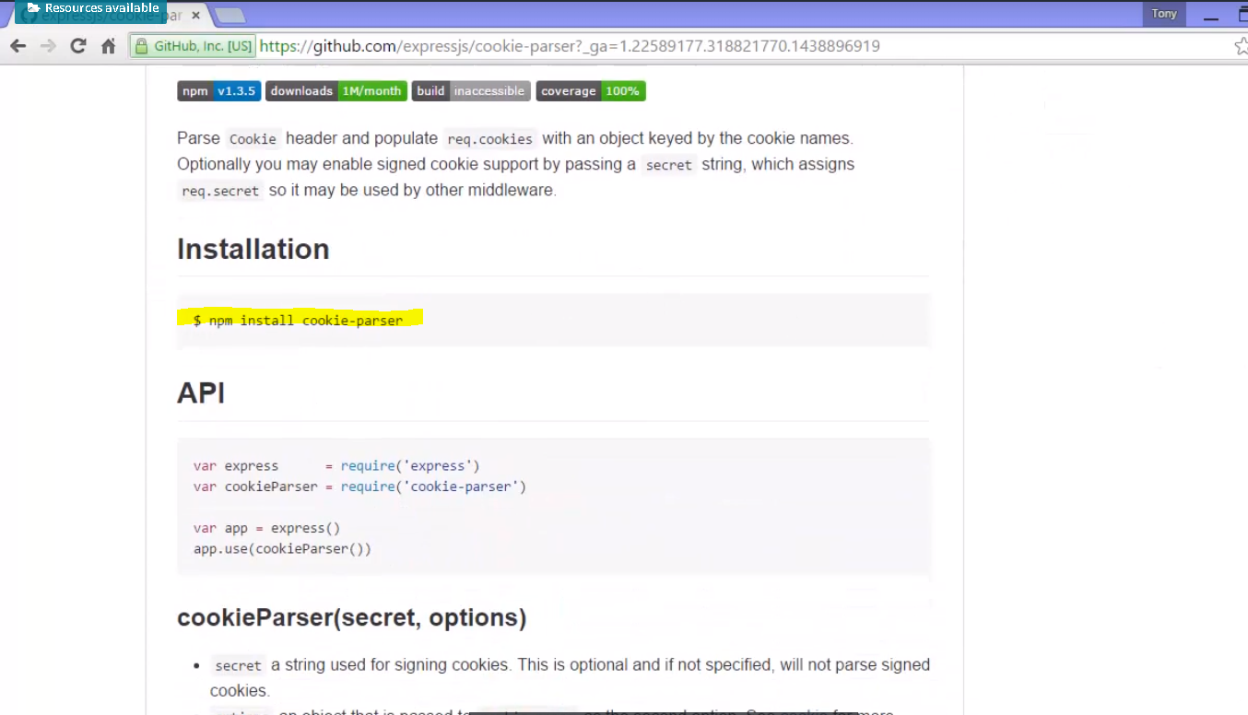

And it also explains example of how to use it. 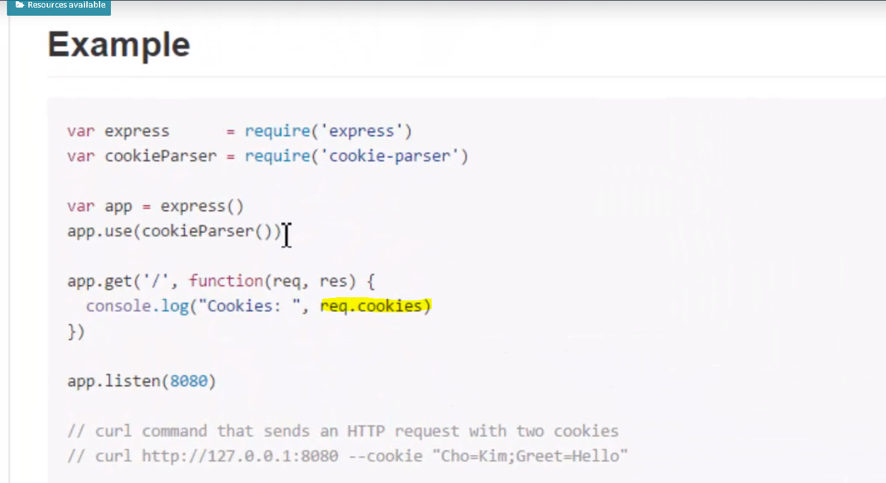

Using it with Express I use .use, and not specifying a route, so it would use it always,

and so this middleware will take the request, the HTTP request, which incidentally includes cookies as a string separated by semicolons.

cookie - **a little piece of information stored on your browser. Well, that gets sent along for the ride with every HTTP request to a particular site, a cookie for that site.**

**So, this pulls that out of the HTTP request, that string, breaks it apart, and then adds it as a .cookies property to the request, and then calls next , so that when you go to get the route you can just grab the .cookies property and get all the values in the cookie.**

That way, you might have some specific piece of information you stored in the cookie and need to get out that was over on the person's browser.

there's lots of other examples. There's body-parser, compression.

There's something very popular

called passport for authentication to make sure someone is properly logged in before you actually respond with the data, before you finish giving them the response, and it helps you to authenticate the person, that is make sure they're logged in via their own username and password for your site or via something called OAuth, which are things like logging in via Facebook or Twitter and other things.

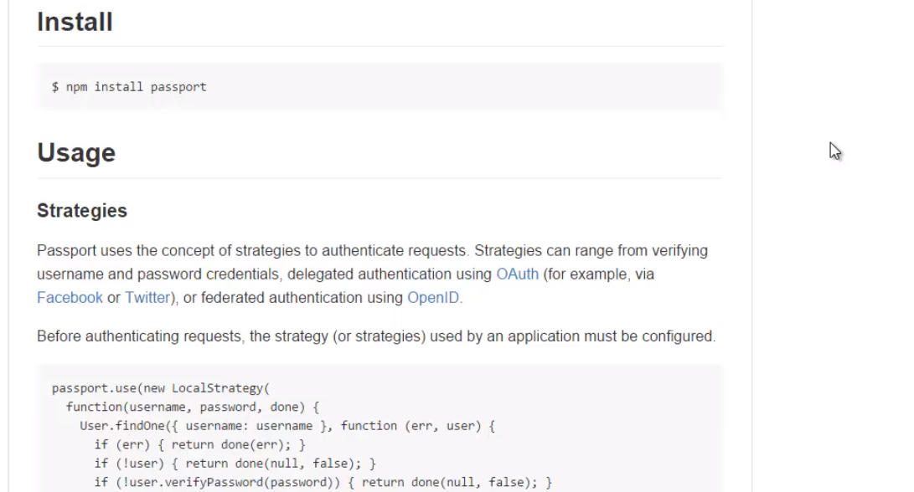

**The idea is simply that via npm you install some JavaScript code that deals with a standard Express request and an Express response. That's Express middleware.**

It's in the middle between those two, and that doesn't mean that you can't then have your own middleware or do something after the fact, because you can just keep going. The middleware can pass the request and responses to each other down a chain and just keep on doing things until we're actually ready to send the response.

## 76. Templates and Template Engine

Express comes with the ability to plug in a whole variety of template engines.

A **template engine** enables you to use static template files in your application. At runtime, the template engine replaces variables in a template file with actual values, and transforms the template into an HTML file sent to the client. This approach makes it easier to design an HTML page.

Some popular template engines that work with Express are [Pug](https://pugjs.org/api/getting-started.html), [Mustache](https://www.npmjs.com/package/mustache), and [EJS](https://www.npmjs.com/package/ejs). The [Express application generator](https://expressjs.com/en/starter/generator.html) uses [Jade](https://www.npmjs.com/package/jade)as its default, but it also supports several others.

**Note**: Jade has been renamed to [Pug](https://www.npmjs.com/package/pug). You can continue to use Jade in your app, and it will work just fine. However if you want the latest updates to the template engine, you must replace Jade with Pug in your app.

**To render template files, set the following**[**application setting properties**](https://expressjs.com/en/4x/api.html#app.set)**, set in app.js in the default app created by the generator:**

* **views, the directory where the template files are located. Eg: app.set('views', './views'). This defaults to the viewsdirectory in the application root directory.**
* **view engine, the template engine to use. For example, to use the Pug template engine: app.set('view engine', 'pug').**

Then install the corresponding template engine npm package; for example to install Pug:

$ npm install pug --save

After the view engine is set, you don’t have to specify the engine or load the template engine module in your app; Express loads the module internally, as shown below (for the above example).

app.set('view engine', 'pug')

Create a Pug template file named index.pug in the views directory, with the following content:

html

head

title= title

body

h1= message

Then create a route to render the index.pug file. If the view engine property is not set, you must specify the extension of the view file. Otherwise, you can omit it.

app.get('/', function (req, res) {

res.render('index', { title: 'Hey', message: 'Hello there!' })

})

When you make a request to the home page, the index.pug file will be rendered as HTML.

Note: The view engine cache does not cache the contents of the template’s output, only the underlying template itself. The view is still re-rendered with every request even when the cache is on.

Example – ejs template engine

It uses these delimiters, a less than percent sign and a percent sign greater than, and then equals when you want to output, and between these, you can put JavaScript code.

Express gives me the means, then, to connect the URL of the file to the route and as well as the data that the template might need to use and the code that's actually inside the template.

The first thing I'll do is npm instal ejs, and save it to my package .JSON as a dependency, because my app will be dependent on EJS being there in order to run. Of course, EJS is just JavaScript code, just like Express is. That installed, and now it's in my node_modules. EJS is built, so that will automatically integrate with Express.

Then, I can specify with app.set view engine, and the file extension I'll use for my files will just be EJS so that it knows where to find those files.

**Now, by default, and you can change this**

**with app.set('views', './views')**

**but by default, the Express framework will look for the files, the static files, what they call the views, inside a folder called views.**

Views really just means your user interface, your UI.

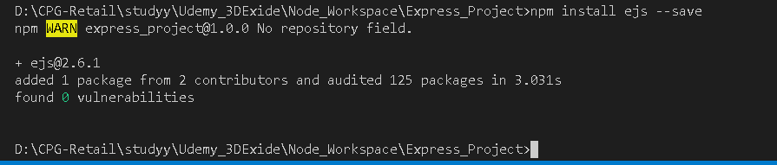

so you should try a few different view engines(Template engine). All you have to do is instal them via NPM and then set whatever the file extension you're going to use for them is, and then simply set your page, put it inside views, call render, give it a model, an object, if you need, and then try it out. Try out if statements and loops.

This took care of the idea of dynamically generating html on the fly. This makes Express, combined with the idea of view engines,

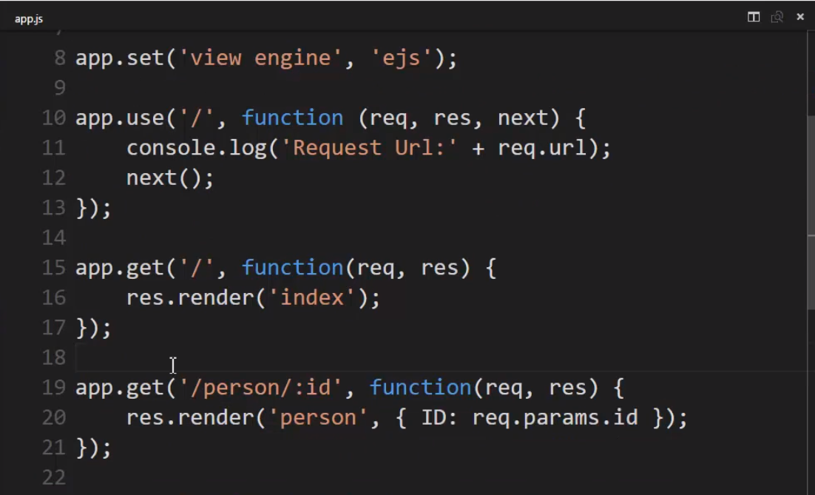

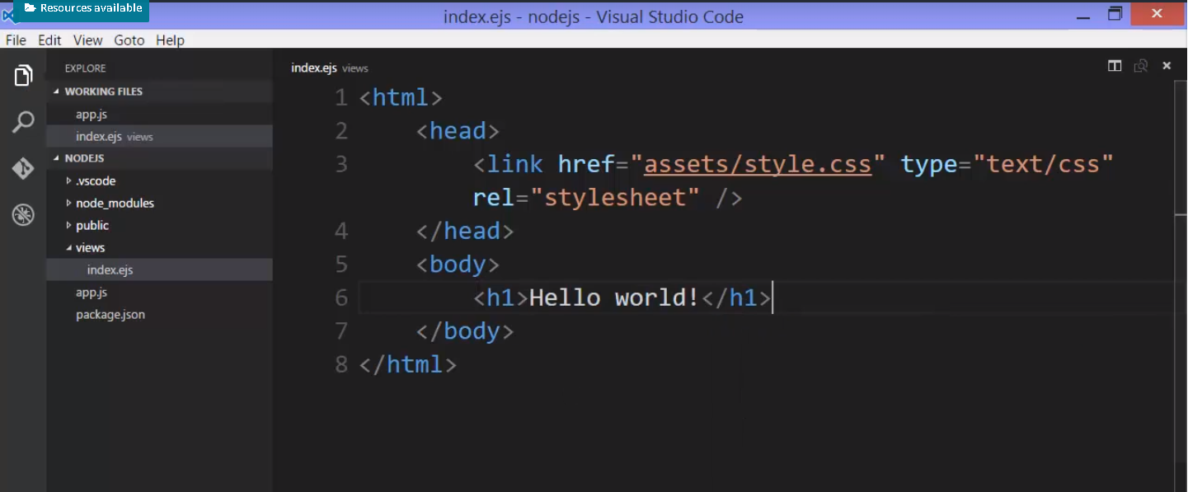

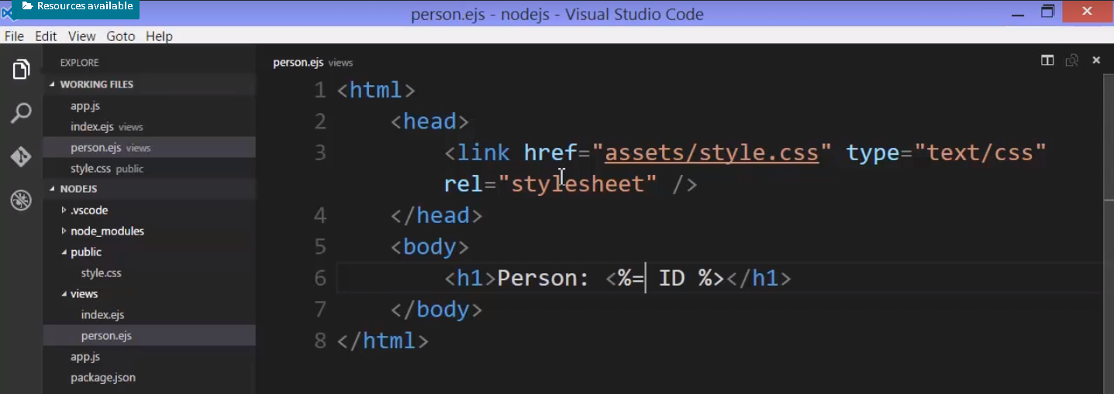

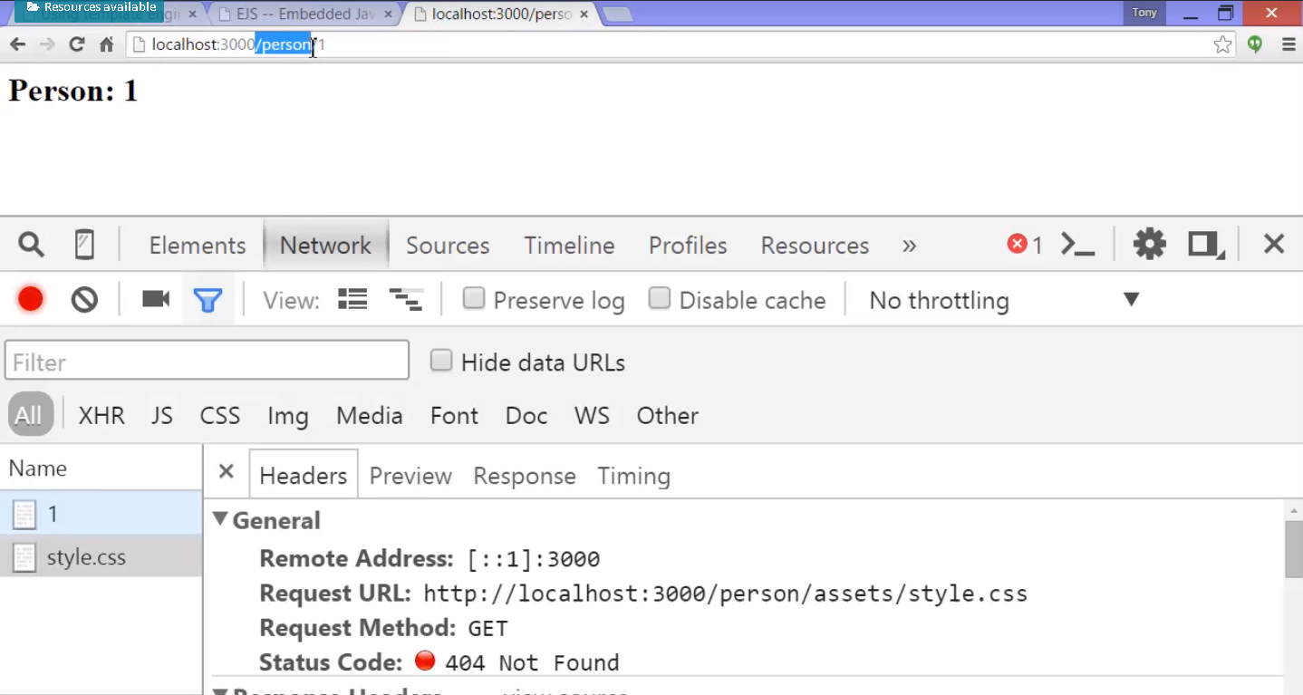

Now, you might notice that the style sheet is wrong. It doesn't have the proper font. You know, that's one of those mistakes you can make when you're dealing with dynamically generated things, especially dynamically generated URLs. Even though we know there is no /person folder, to the browser, that's what we're asking for, and so when it asks for assets/style,

now that we're under /person, it's keeping that as part of the URL. I really need to make sure that it's understanding that we're asking particularly

for it at the root. I just put a slash in front, and then that took care of it.

**Note –**

**/assets/style.css – means from root got to assets/style.css**

**assets/style.css – means from current url to assets/style.css**

**./assets/style.css – means in the same level at this file to assets/style.css**

**../assets/style.css – means one folder above to the current file to assets/style.css**

It's those kind of things that you have to think about, and you can miss, when you aren't really thinking about folders, but you have to remember that the browser doesn't understand what's happening behind the scenes in your Node app. It only knows what it has from an http request and response perspective.

## 77. QueryString and post parameters

let's talk now about getting querystring and post parameters in data from HTTP requests in Express.

So when the browser sends, for example, a GET request, and we're talking about the querystring, well that appears in the URL up in the browser.

When the browser actually builds the GET request, however, what you'll see is the querystrings here in the header of the actual request.



So we need to then parse the HTTP request, pull out that data, and put it into a format that we can use in our code.

And by the way, cookies are also coming along for the ride, any cookies stored in your browser.

Then, in the case of posting data, when you have a form on a webpage and you hit the submit button, the browser forms a POST, and the content type is application/x-www-form-urlencoded.

querystring is moved into the body of the HTTP request so you no longer see it in the URL because it's no longer part of the URL,

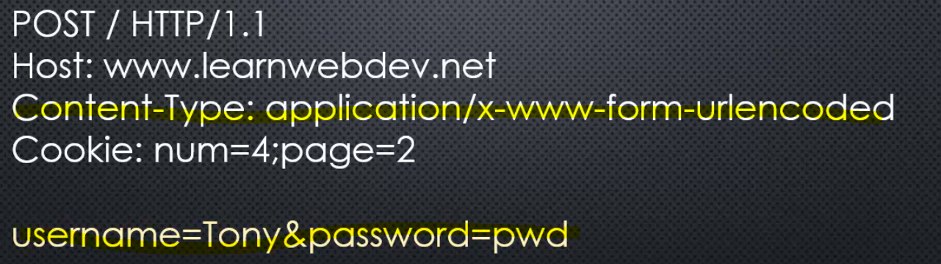

when you end up sending JSON data from the browser, maybe using a tool like jQuery to help you send some JavaScript objects on the browser side, on the client side, well, then you end up with a content type of application/json and your actual JSON, the string, is also in the body, much like it is when you're posting a form.

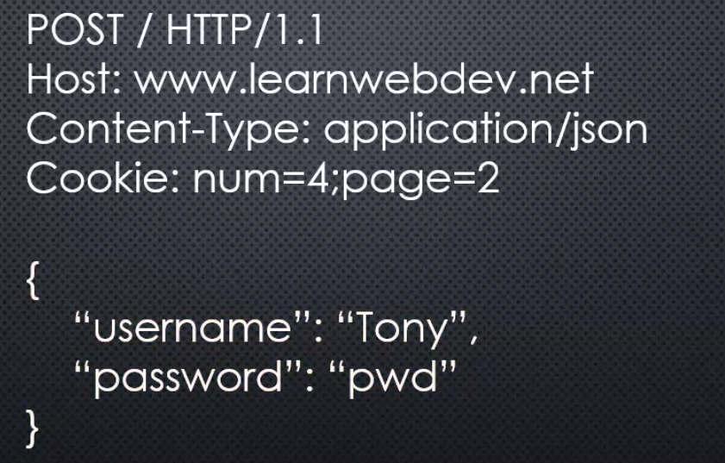

So each of these things has to do with the format of the HTTP request, and so in order to get the data out, we're going to need some middleware in some cases

### **Get Query String(Parameter) and Path parameter from request**

 Querystring (or Path parameter) is by far the easiest because the express request object already parses it out for us. So if the querystring, that part that's up in the URL when you see it in the browser, and is actually right there in the header part of the request when an HTTP request comes in.

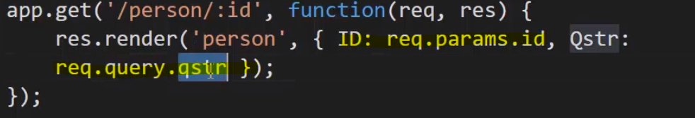

So now that means that this object should end up having the querystring value and any name value pair will then be parsed and attached to this query object that exists on the request wrapping object that Express provides and the query object will just be empty if there is no querystring.

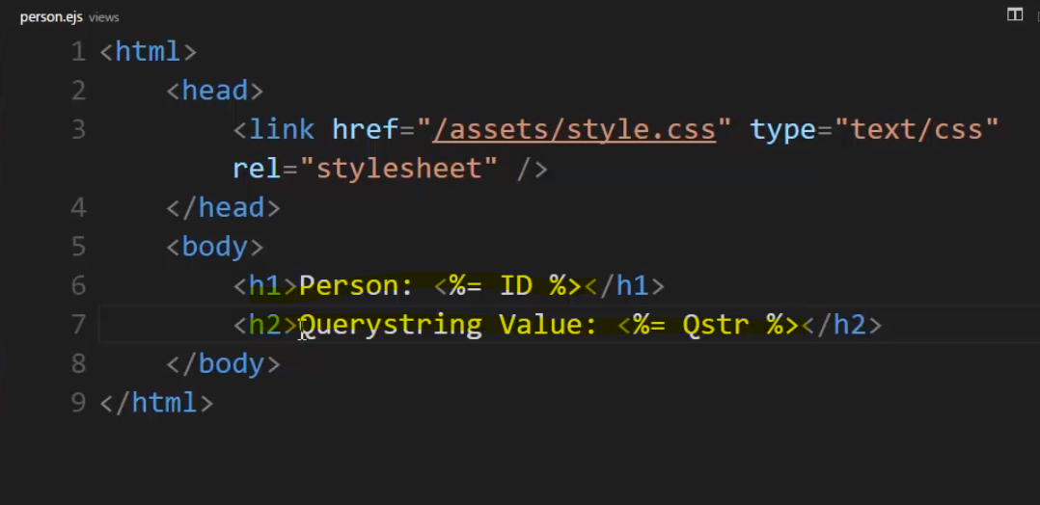

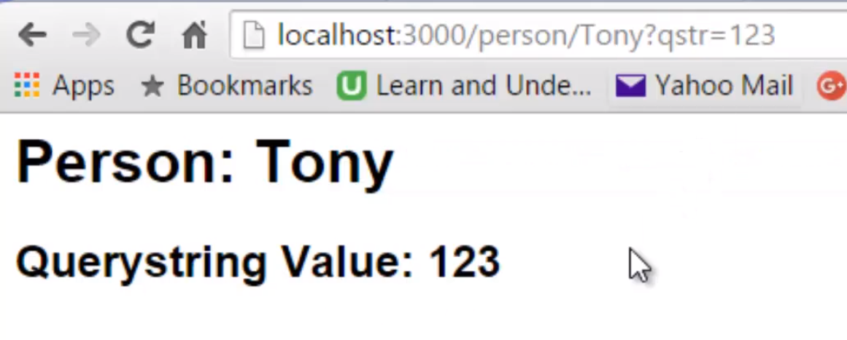 **So this generated an HTTP request that included the path parameter and querystring in the header, and so that was parsed and made available to me in Express via the .query object as a property on the query object.**

### **Getting Post Parameters**

However if we want to deal with a form being posted or with JSON data being posted,

we'll need to be able to parse the body of the HTTP request and that's not something that Express is doing just out of the box.

**That means we'll need to go back to our middleware. We need something between the request and the response. Something that will look at the request, give us access to that information, parse that content of that HTTP request for us so we can work with it.**

We could do it ourselves, but there's already stuff available. So we'll look at **body parser**.

Node.js body parsing middleware.

**Parse incoming request bodies in a middleware before your handlers, available under the req.body property.**

There are actually more than just one of these body parsing middlewares, but the idea is that it will parse the body.

So we will install it via npm – npm install bady-parser –save

So how do we use it? Well, it's a module, and in this case I am going to actually need to require it because it isn't just going to work like a view engine does. It's not going to automatically hook.

we don't want to parse the body for every single HTTP request, just for POSTs, just for certain ones.

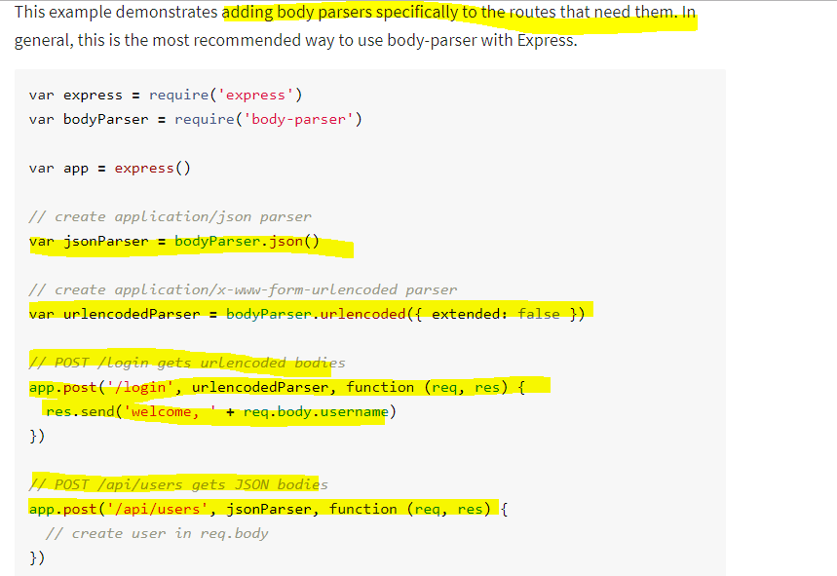

**we have to pass it as a callback to the POST statement. You see, these methods take other callbacks.**

**The good thing about doing it this way as opposed to just .use , is that it makes certain that the HTTP request is formatted properly for what's expected from the parser.**

**So here's our URL encoded parser, and that will receive what it needs to actually parse the body.**

**And this will be middleware that will be called before this function is called. So very** **similar to when we said app.use.**

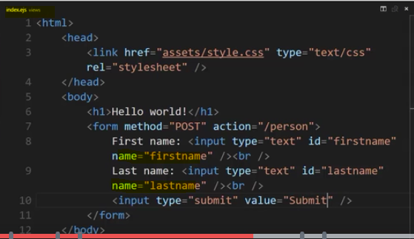

So what the browser does is when we submit this form, the browser takes the values I've typed into these fields, uses name attribute as the name, and sets up that querystring, name equals value based on what I typed in.

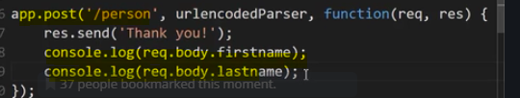

**Example with json parser -** 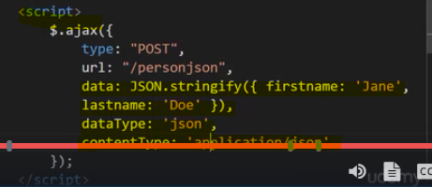

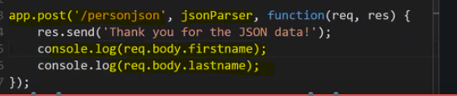

## 78. Restful api and JSON

RESTful APIs and JSON made easy with Express.

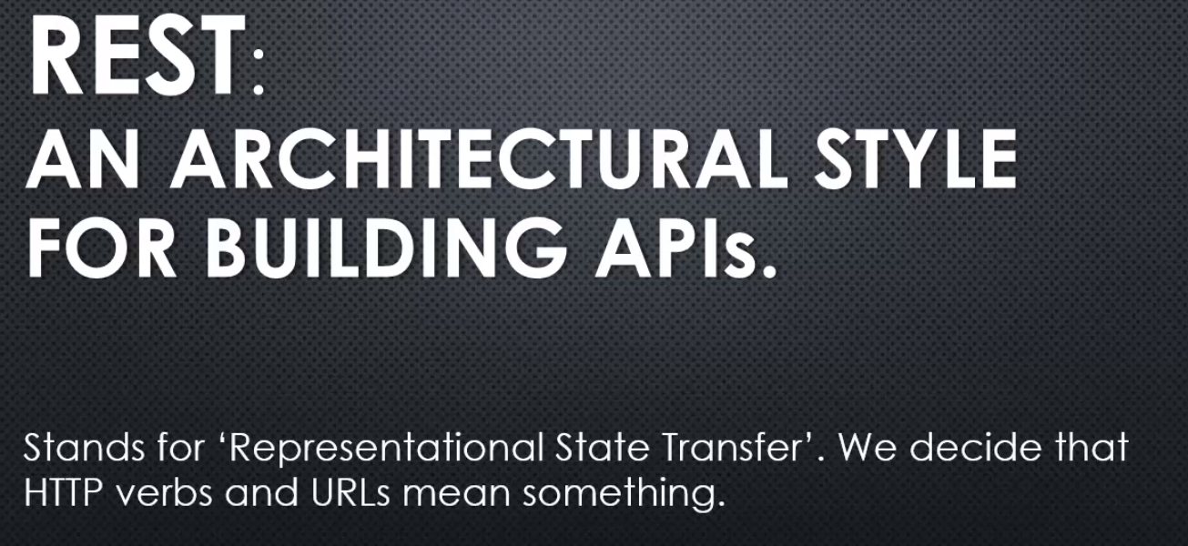

**all it really means is that when we handle HTTP requests, we decide that the verbs and the URLs mean something. When we build our APIs, we build them in a way that the verbs and URLs mean something, because it's up to us how we handle the requests on the server.**

We could come up with some complex way of sending and receiving all data through just get requests.

But, REST is a way of saying, let's standardise on a way of using the HTTP requests so that when they're sent, when you read them, they kind of match what's actually happening.

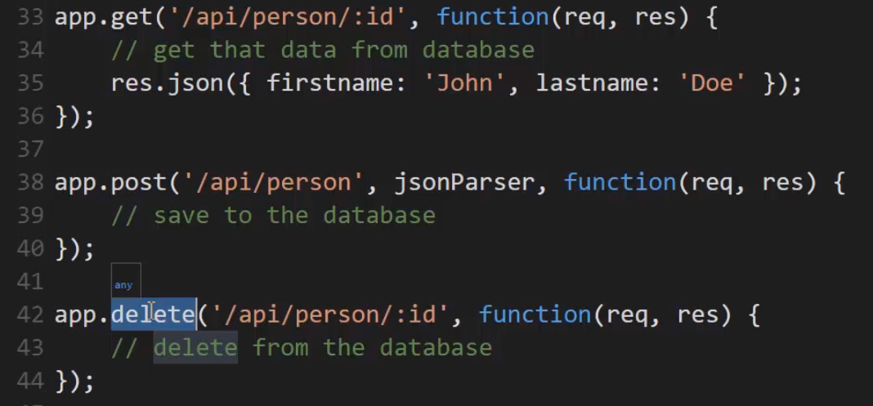

**So, having a RESTful API means that**

**you design your API so that it responds to the HTTP request verbs, the methods, in the way that it's expected. And you also look at the URL and understand what it's doing.**

**So if I combine this URL, I see /person and an ID, and I combine that with the HTTP method being used, I can pretty much guess what this is going to do.**

I sent an HTTP request with the delete verb to a /person address, with an ID, I can pretty much guess that this API is going to delete that person out of the database. And that's all the idea of a RESTful API really is.

So, when you hear the phrase, we can build a RESTful API, don't be confused or intimidated by it. It just means, follow a good URL structure, and deal with HTTP methods the way that one would anticipate. And that's made very easy with Express

because it already allows us to deal with different methods in this very direct way. Just calling a function, mapping to a URL, and giving it a callback. So it's very simple to build basic REST APIs with Express.

## **79. Structuring an Application**

in the real world of web app development, things get big and complex really quickly.

So let's look at some ways to structure an application across multiple files in Express.

in a real world web application, you're going to end up with a lot of pages, a lot of endpoints, a lot of JavaScript, and so sticking it all in one app.js file just won't work.

What kind of architectural approach might we take? And the answer is there's lots of options.

Express is an unopinionated framework meaning we have lots of choice.

**Express does try to help us at least get an idea of what we might do. Under Getting Started, there's something called the Express Generator. This lets us very quickly create an application skeleton.**

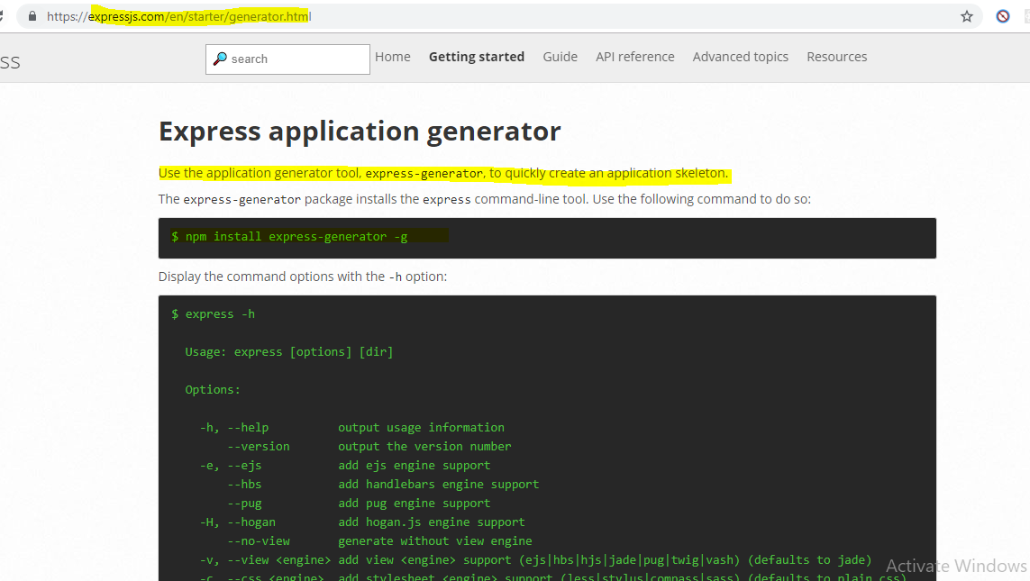

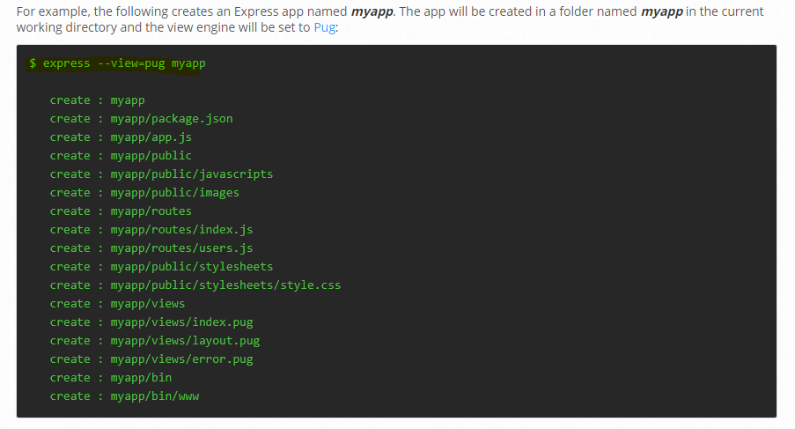

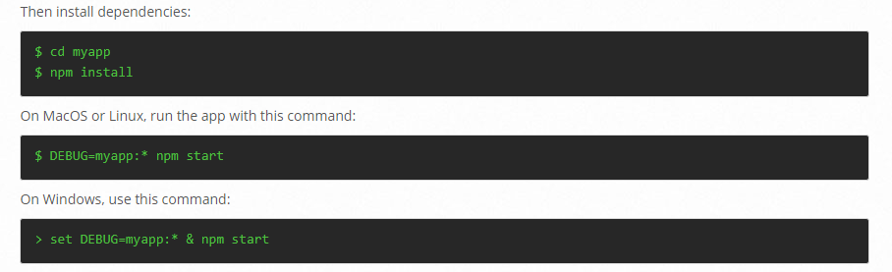

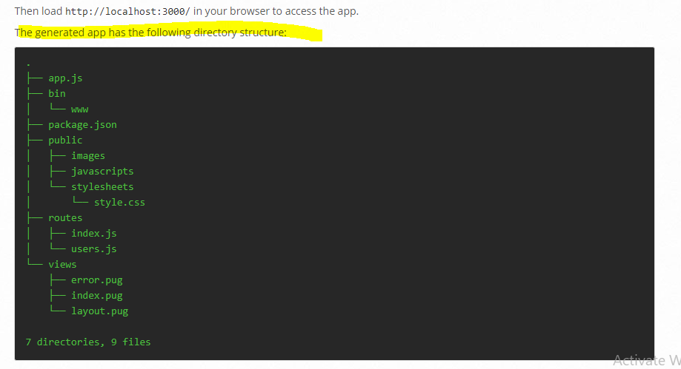

 I'm just in an empty folder here that I created. And I can just say express and then say the name of the folder that I want to create that will contain all of this code.

Let's call it myapp, and we can see that it created a bunch of files. Now I need to go in there because it created a package.json and do npm instal. The package.json that was created by running Express and then the folder name has all of the things we need to run this app.



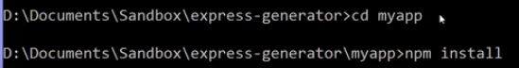

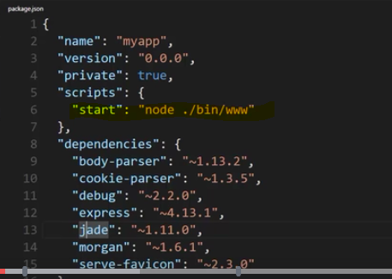

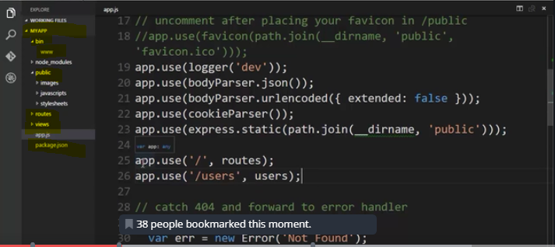

**Lets make our custom structure of our application**

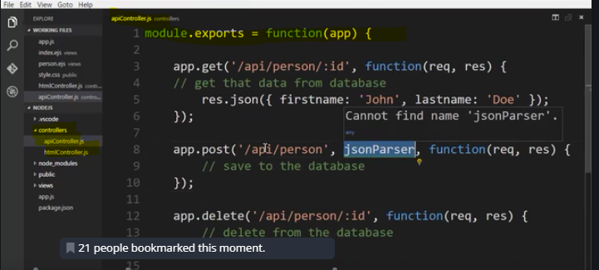

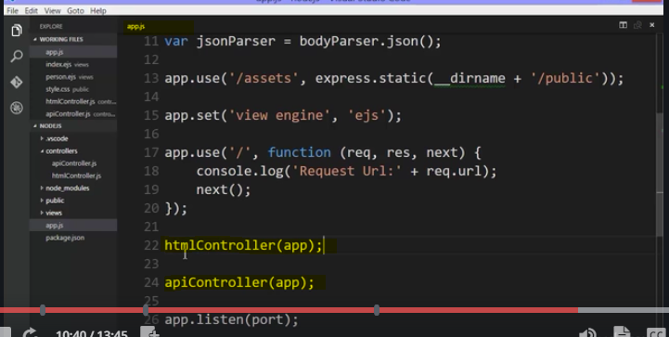

**So both of these lines are adding on to the app because it's passed by reference.**

So I'm just taking the exact same code and splitting it up into module files. This is about organising the structure of your application. So as things get big, you'll want to decide how you like splitting up the various things that you need to do in your app.

And this is important for maintenance, for other coders who have to come in and use your code. And remember that modules is what node has provided to make this easier.

So we can separate our code into modules, pass things around or use internal features like express.router in order to make it easier to organise our app.

And if you're asking what's the best way to do this, there is no specific answer. So try different things.

Look at patterns out there on the internet. Look at some of this code. Look at the code in the Express Generator.